
RAMAIAH
Institute of Technology
USN | 1 | M | S

(Autonomous Institute, Affiliated to VTU)
(Approved by AICTE, New Delhi & Govt. of Karnataka) Accredited by NBA & NAAC with ‘A+’ Grade

EXAMINATIONS SEPTEMBER /OCTOBER 2021
SUPPLEMENTARY SEMESTER / GRADE IMPROVEMENT/ RE –REGISTERED CANDIDATES
Program | : | B.E. : Electrical and Electronics Engineering | Semester | : | V
Course Name | : | Signals and Systems | Max. Marks | : | 100
Course Code | : | EE51 | Duration | : | 3 Hrs

Instructions to the Candidates:
- Answer any five full questions.
- Suitably assume any missing data.

1. | a) | Briefly explain the properties of a system. Given (i)= (ii) = . Determine the properties of the system. | CO1 | (08)
 | b) | i)Determine the fundamental period of the signal  ii) Given y(t)=y₁(t)+y₂(t)+y₃(t) where y₁(t), y₂(t) and y₃(t) have periods of 1.08, 3.6 and 2.025 respectively. Find the time period of y(t) | CO1 | (08)
 | c) | Differentiate between power and energy signal with necessary examples. | CO1 | (04)
2. | a) | Define even and odd signals. Find odd and even parts of x[t] given in Fig.2(a)  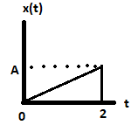  Fig.2(a) | CO1 | (06)
 | b) | Sketch the signals  i) x(t)=r(t+1)-r(t)+r(t-2) ii) x(t)= -u(t+3)+2u(t+1)-2u(t-1)+u(t-3) where r(t) and u(t) represents unit ramp and unit step function respectively. | CO1 | (08)
 | c) | Determine whether the systems i) ii) are linear, time invariant, causal, memoryless and stable. | CO1 | (06)
3. | a) | Given h(t)= u(t) - u(t-3) and x(t)=u(t) - u(t-1). Obtain and plot the output y(t). | CO2 | (10)
 | b) | Evaluate the convolution y(n) for the signals h(n)=u(n)-u(n-3) and x(n)=δ(n)-2 δ(n-1)+ δ(n-2). | CO2 | (10)
4. | a) | Convolute graphically x(t)& h(t) and hence plot the output signal. Given x(t)=2 u(t-1) - 2u(t-3) and h(t)=u(t+1) - 2u(t-1)+u(t-3). | CO2 | (10)
 | b) | Determine and plot the response of the LTI system whose input x(n) and impulse response h(n)are given by x(n)=u(n)- u(n-4) and h(n)=2^{n}{u(n)-u(n-5)}. | CO2 | (10)
5. | a) | State and bring out the importance of sampling theorem. | CO3 | (08)
 | b) | Find the forced response for the following differential equation:  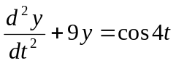 | CO3 | (08)
 | c) | Draw direct form I and direct form II realization of the following systems:  y(n) – 1/9 y(n-2) = 2x(n) + x(n-1) | CO3 | (04)
6. | a) | Find the complete response for the following differential equation  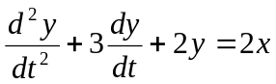  Given y(0) = -1, y¹(0) = 1 and x(t) = cost u(t). | CO3 | (10)
 | b) | Draw direct form I and direct form II realization of the following systems  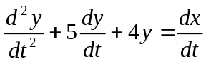 | CO3 | (05)
 | c) | What is quantization? Explain the significance of quantization. | CO3 | (05)
7. | a) | State and explain the following properties of DTFS  (i) Linearity (ii) Convolution (iii) Parseval’s property. | CO4 | (10)
 | b) | 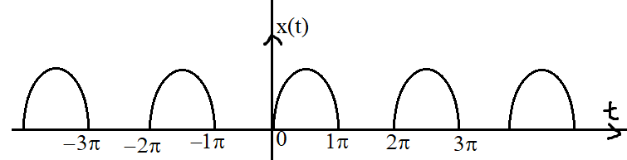  Find the trigonometric Fourier series for the half rectified sine-wave shown below and sketch the line spectrum. | CO4 | (10)
8. | a) | State and explain the following properties of DTFT  (i) Linearity (ii) Time shift (iii) Modulation (iv) frequency shift. | CO4 | (10)
 | b) | Determine the DTFT the following:  (i) x₁(n) = {1,-1,2,2} (ii) x₂(n) =(0.5)^{n}u(n) + 2^{n} u(-n-1) | CO4 | (10)
9. | a) | What is the significance of ROC of a Z transform? List the properties of ROC. | CO5 | (06)
 | b) | Find the z-transforms of the following signals, depict the ROC with poles and zeros on the z – plane.  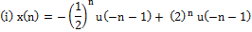  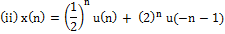 | CO5 | (08)
 | c) | Find the inverse Z-transform of  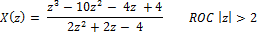 | CO5 | (06)
10. | a) | Determine the ROC and z – transform of the signal  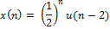  Sketch the ROC and plot poles and zeros in the z – plane. | CO5 | (10)
 | b) | A causal system has the input x[n] and output y[n]. Use the transform function to determine the impulse response of this system:  x[n] = δ(n)+ δ(n-1) +δ(n-2) and y[n] = δ(n)- δ(n-1) | CO5 | (10)

****************

